Role Framework Management Training Guide
ID Central – Role management

1. Document Purpose

Objective
This document provides guidance to authorized users on how to manage the role framework within ID Central. It explains the process for creating, reviewing, updating, approving, and retiring roles used to assign access to users.
Users responsible for managing the role framework may create new roles, update existing role details, define role ownership, manage Inherited roles and submit role changes through the appropriate approval process.

Audience
The audience for this document includes users who are authorized to manage, review, approve or support roles within ID Central. This may include:
- IAM Team
- Role Owners
- Role Administrators

Scope
This guide provides instructions for managing the complete role of lifecycle within the ID Central Role Management Functionality.

The guide covers:
- View and search for existing roles.
- Creating new Business, functional and IT roles.
- Updating and maintaining role details and descriptions.
- Assigning role owners and approvers.
- Associating applications, entitlements and access groups with roles.
- Updating existing role definitions and access mappings.
- Submitting role creation or modification requests for approval.
- Reviewing and approving role changes.

Process Steps

IT Role Creation
IT Roles are collections of required permissions and entitlements. They serve as the base container that groups related entitlements required to perform a specific job function or access requirement.

Step 1: Login to ID Central
Steps:
- Open the SailPoint IdentityIQ application.
- Enter valid credentials.
- Login successfully.

Step 2: Navigate to Roles
Steps:
- Navigate to setup > Roles
- Select the option to create a new Role, select Role.
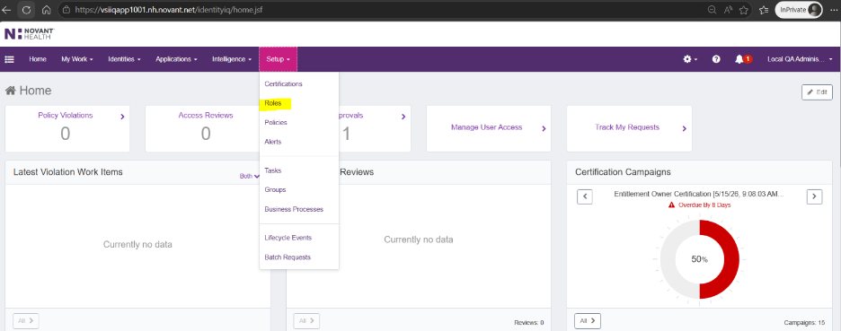
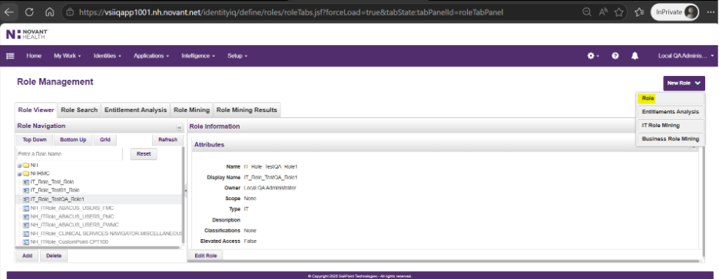

Step 3: Configure IT Role
Steps:
- Fill the mandatory field on the Role Editor page.
- In the Name field, enter a unique system name for the IT role.
- Enter the Display Name, Type = IT Role and select the appropriate owner of the Role.
- Add the description for anyone viewing the role to understand (Optional field).
  - The Purpose of the role.
  - Which users should receive the role.
  - The type of access included in the role.
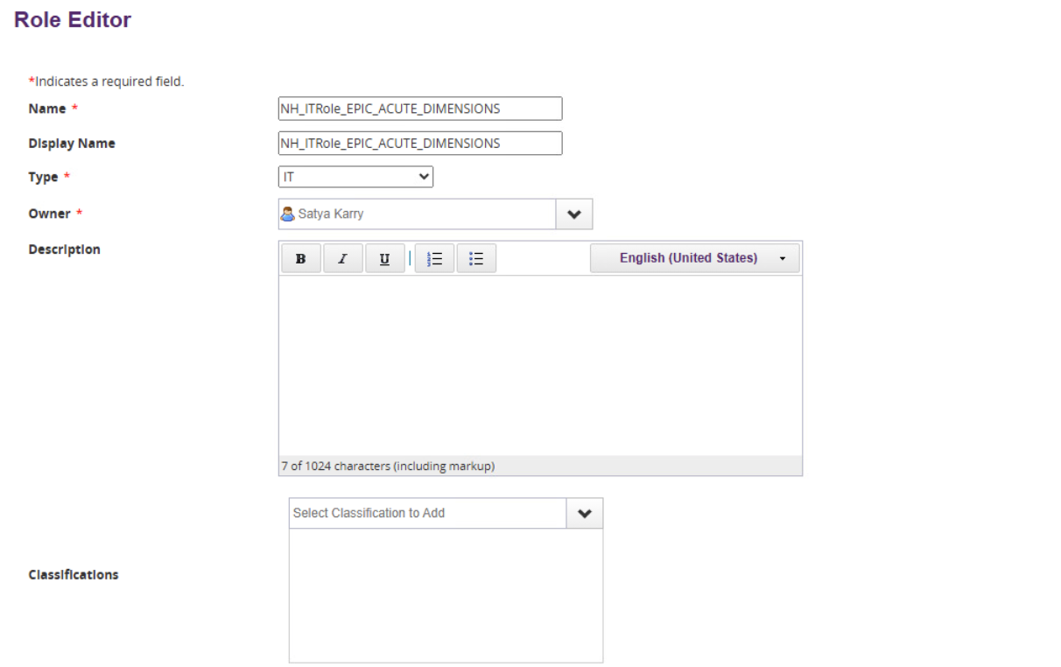

Step 4: Configure the Entitlements
Steps:
- Add the required entitlements by selecting the appropriate Application, Entitlement Type, and Entitlement Value.
- Repeat the entitlement selection process until all required entitlements have been added. Multiple entitlements from one or more applications can be associated with the same role.
- Review the role configuration to ensure all required details and entitlements have been added correctly.

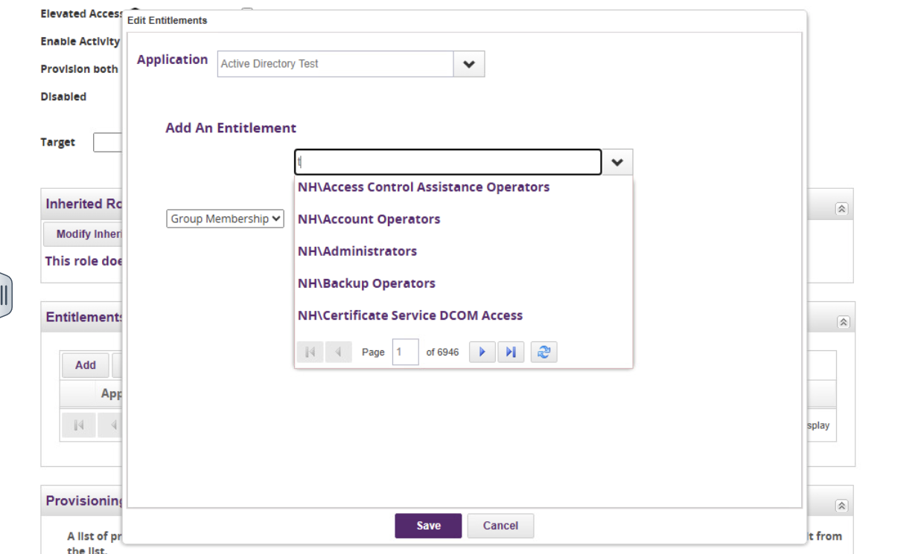
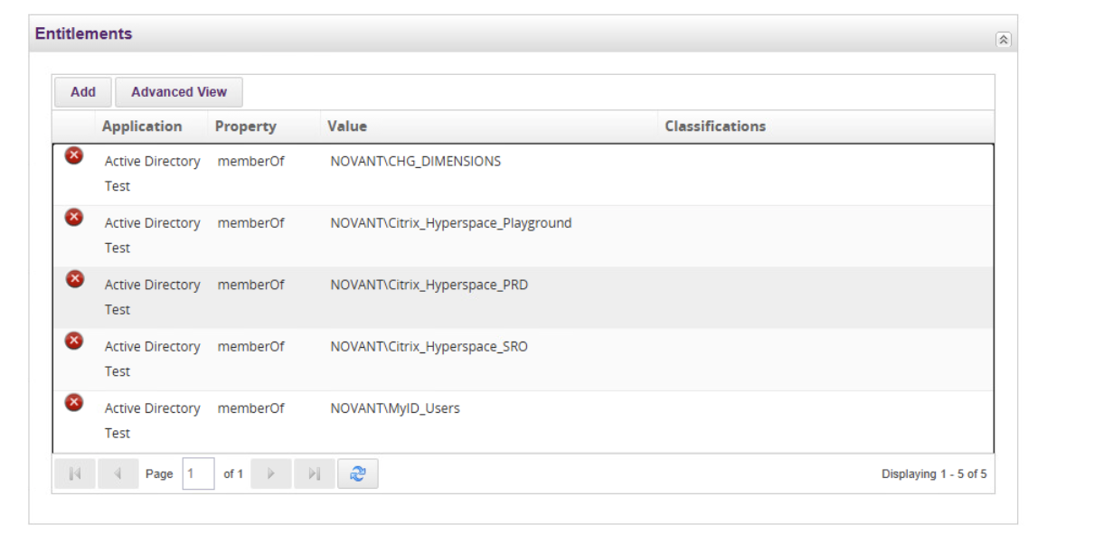

Step 5: Submit the IT Role
Steps:
- Review the complete role configuration.
- Submit the IT role

IT Role Update

Step 1: Navigate to Roles
Steps:
- Navigate to setup > Roles
- On the left hand side, Open the IT Role by clicking on its name or selecting Edit from the available actions.


Step 2: Modify IT Role
- Modify the field on the Role Editor page.
- Name, Display Name, we can even modify the role owner, Role type should not be modified
- Description of the role can be modified

Step 3: Modify the Entitlements
- Modify the role entitlements by adding new entitlements, removing obsolete entitlements, or updating existing entitlement assignments
- Repeat the entitlement modification process until all required changes have been completed.
- Review the updated role configuration to ensure all changes are accurate and aligned with business requirements.

Step 4: Save and update the IT Role
- Click Save to submit the updated IT Role
- Verify that the IT Role is successfully updated and the latest configuration is available for user assignments.
- Navigate to Intelligence > Advanced Analytics > Audit Events and verify that audit records have been generated for the IT Role update activity.

Business Role Creation
Business Roles are the primary container used to represent a user's job function. They group one or more related IT Roles and, when assigned to a user, automatically assign the associated IT Roles, which then provision the required application access and entitlements.
Before creating a business role, IT role should be already created and available to be an association.

Step 1: Login to ID Central
Steps:
- Open the SailPoint IdentityIQ application.
- Enter valid credentials.
- Login successfully.

Step 2: Navigate to Roles
Steps:
- Navigate to setup > Roles
- Select the option to create a new Role, select Role.



Step 3: Configure Business Role
Steps:
- Fill the mandatory field on the Role Editor page.
- In the Name field, enter a unique system name for the Business role.
- Enter the Display Name, Type = Business Role and select the appropriate owner of the Role.
- Add the description for anyone viewing the role to understand (Optional field).
  - The Business Purpose of the role.
  - Which users should receive the role.
  - The type of access included in the role.
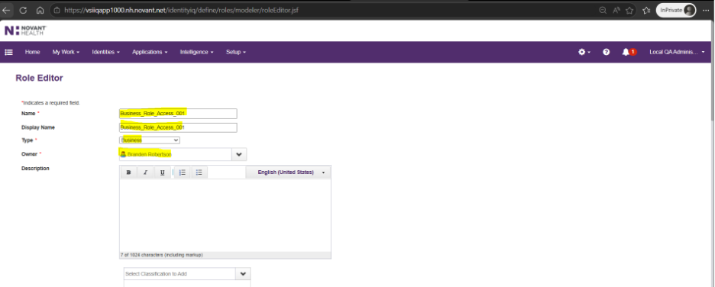

Step 4: Configure the Assignment Rules
Steps:
- Select the disabled to True while creating a Business Role.
- Navigate to the Assignment Rules.
- Select the “Match List” in the drop down to select the attributes to match eligibility.
- Choose the identity attribute that will be used to determine role eligibility.
  - Example: Department number equals the required value.
- Add additional Conditions are required.
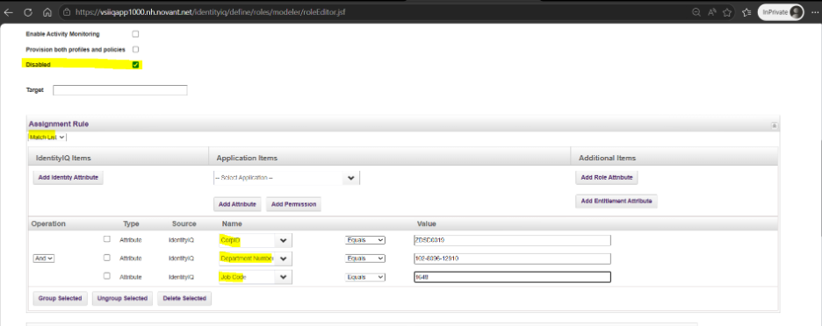

Step 5: Configure the Required Roles
Steps:
- Locate the Required Roles sections on the role configuration page.
- Select the “Modify Required Roles”.
- Add the Required IT Roles as a part of the Business role.
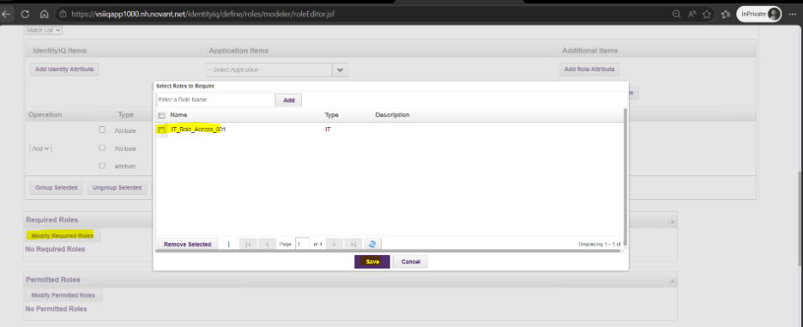

Step 6: Submit the Business Role
Steps:
- Review the complete role configuration.
- Submit the Business role to create

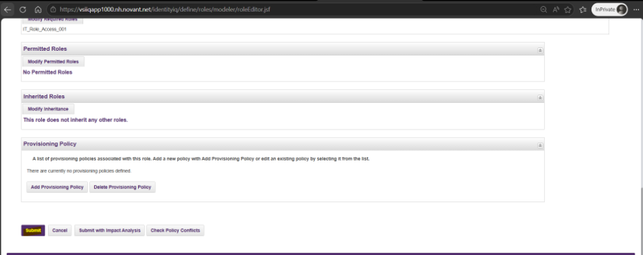

Business Role Update

Step 1: Navigate to Roles
Steps:
- Navigate to setup > Roles
- On the left hand side, Open the Business Role by clicking on its name or selecting Edit from the available actions.

Step 2: Modify Business Role
- Modify the field on the Role Editor page.
- Name, Display Name, we can even modify the role owner, Role type should not be modified
- Description of the role can be modified

Step 3: Modify the Assignment Rules
- Modify the Assignment Rules.
- Select the “Match List” in the drop down to modify the attributes to match eligibility.
- Choose the identity attribute that will be used to determine role eligibility.
Example: Department number equals the required value.
- Add or remove additional Conditions are required.



Step 5: Configure the Required Roles
Steps:
- Locate the Required Roles sections on the role configuration page.
- Select the “Modify Required Roles”.
- Add or remove the Required IT Roles as a part of the Business role.


Step 6: Save and update the Business Role
- Click Save to submit the updated Business Role
- Verify that the Business Role is successfully updated and the latest configuration is available for user assignments.
- Navigate to Intelligence > Advanced Analytics > Audit Events and verify that audit records have been generated for the IT Role update activity.

Role Delete

Step 1: Navigate to Roles
Steps:
- Navigate to setup > Roles
- On the left hand side, Open the Role by clicking on its name or selecting Delete from the available actions.



Step 2: Delete Role
- Review the confirmation message and confirm the deletion of the Role.
- verify that the Role has been successfully removed and is no longer available in the Roles list or assignment to users.
- If the Role being deleted is a Business Role, only the Business Role is deleted. Any associated IT Roles remain unchanged and are not deleted.
- Navigate to Intelligence > Advanced Analytics > Audit Events and verify that an audit record has been generated for the IT Role deletion activity.

